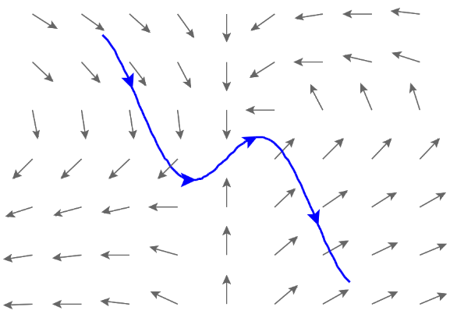
5.2.2 Work Integrals

Motivation: Suppose, as in the last section, we have a curve C that we are interested in travelling along, but we are now wanting to move along this curve through a vector field.

In the last section we saw that a line integral was useful for “adding up” a quantity as we progressed along a path. In this section we are interested in the vector field’s effect on the motion of an object along the curve C, specifically in regards to the amount of work done by the vector field on any object that traverses C.

When the vector field is moving with the direction of the curve it contributes positive work in the motion of an object along the curve. When the vector field is moving against the direction of the curve it contributes negative work in the motion of an object along the curve.

Exploration: Suppose that is a continuous vector field. Suppose also that models some force field in space (for example F could represent a gravitational field or an electric force field).

Suppose a particle moves through this force field along a smooth curve C which is given by the parameterization where . Suppose that the particle starts its movement at the point and ends its movement at the point . We want to know the amount of work done by F on the particle as it moves from to .

So, by the way work is defined, the work done by F on the particle as the particle moves from to is approximately:

Thus, the total work done by the force F in moving the particle along C is:

We know that , and from chapter 2 we know that .
So, we have:

Definition: Let F be a continuous vector field defined on a smooth curve C given by a vector function where . Then, the line integral of F along C is

Note: We will address an intuitive meaning of dr in the next example. One should note that F may have any number of components and the above definition will still apply.
Example 1: Find the work done by the force field in moving a particle along the line segment, C, from to . (Notice this is the same as Ex 5 in section 5.2.1!)

Observation:
We can view our resulting work integral as .

Example 2: Find the work done by on a particle which moves along the curve C given by where .

Note: One should draw a picture of the particle’s path and this vector field to see why the work is equal to 0.
Note: One could have solved the above problem with as well.

